----------------------------SETUP----------------------------

We connect the PIR sensor “OUT” to Pin 4

We connect the Relay “IN1” to Pin 8

The ELECTRIC FAN has one of the 220V wire spliced to connect the end connected to the power plug

to the COM(Common) Pin of the Relay module and the one going to the FAN is connected to the

NC(Normally Closed) Pin.

We use a breadboard to connect the VCC and Ground to both modules from our UNO,

but we connect a 1N4007 rectifier Diode to the VCC line of the Relay Module to allow the

current to go only one way.

One important thing that is sometime forgotten is to use a Rectifier Diode when switching High Voltage.

Some Relays have this protection integrated, but these Diode are so cheap, why not add another layer of protection to our circuit. Putting the Diode between the Relay and Arduino, will protect us from power surges when the Relay switches since the Diode only allows current to flow one way.

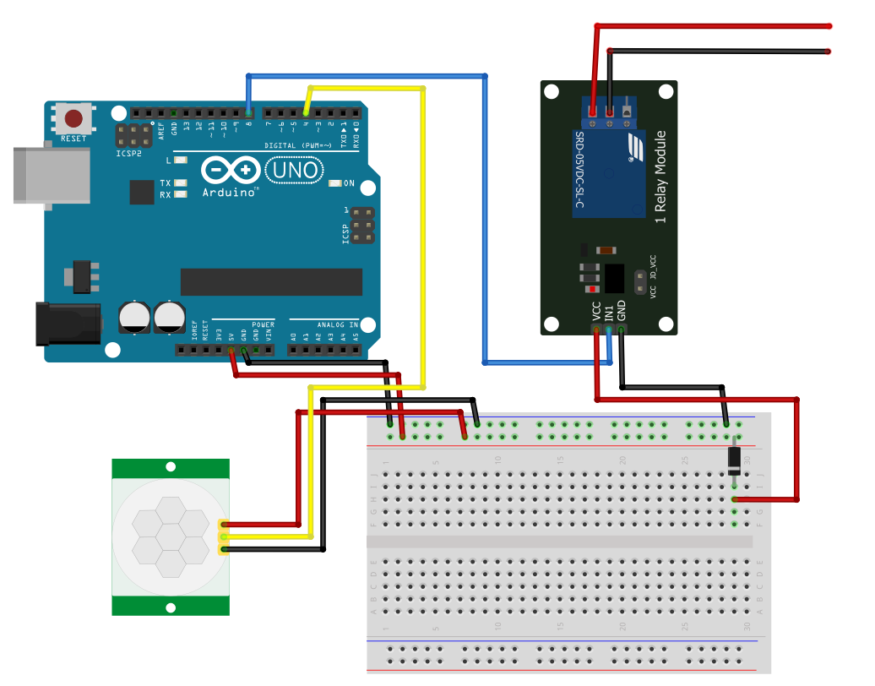

TO FAN

BREAD BOARD

RELAY

PIR SENSOR

ARDUINO

OUT

GND

VCC

COM

NC

NO

GND

5V

RECTIFIER DIODE

PIN 8

PIN 4